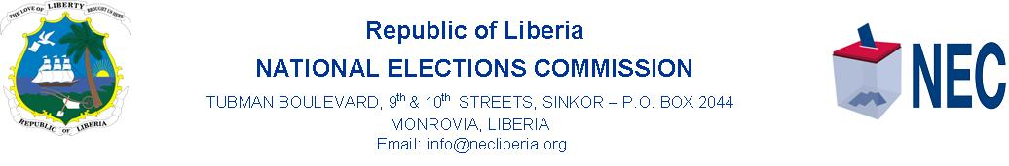
PRESS RELEASE
MOMROVIA, 7 January 2022, Friday, the Board of Commissioners, (BOC), of the National Elections Commission, (NEC), Friday denied and dismissed the appeal action case of fraud, irregularities and violence filed by Melvin Salvage of the Coalition for Democratic Change, CDC, in the 16 November 2021 Bong County electoral dispute case.
The Board of Commissioners has meanwhile, reaffirmed and confirmed its 19 November 2021 ruling declaring Mr. James Kollie of the People Unification Party, PUP as winner of the representative By-election in electoral district #2, in Bong County.
However, Lawyers representing Melvin Salvage and CDC, led by Cllr. Jonathan Massaquoi has accepted the BOC’s ruling and announced an appeal to the Honorable Supreme Court of Liberia.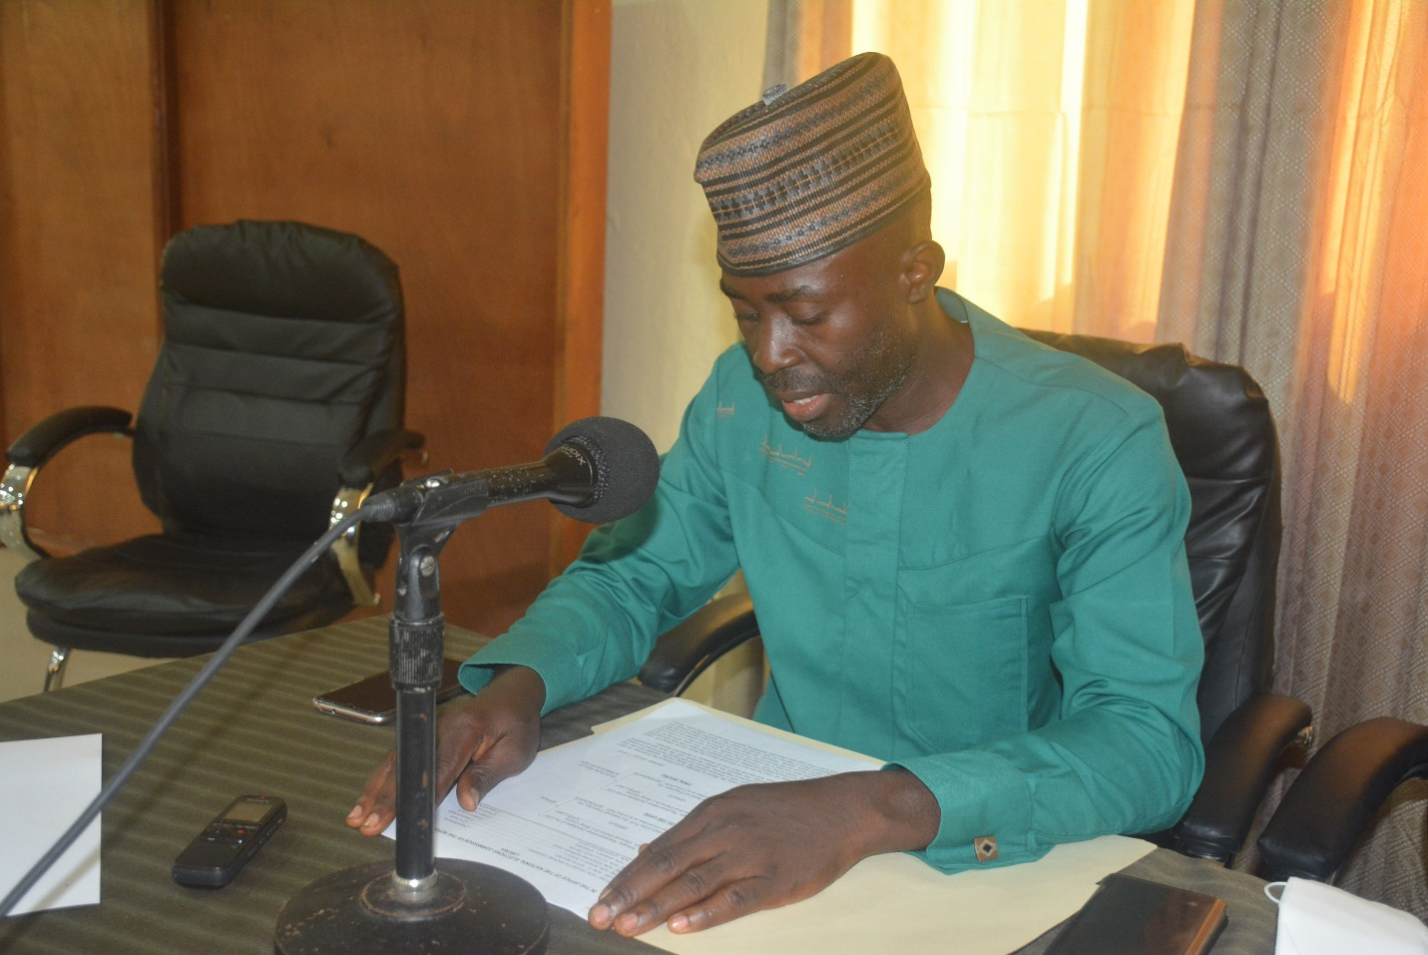
The Clerk of NEC’s Administrative Court, Forfee Sheriff reads the BOC ruling in the Bong County Case.

In the Board’s ruling Friday, 7 January 2022, read by the Clerk of the Administrative Court, Forfee Sheriff, the Board said, its Hearing Officer did not err in dismissing the appeal action case because the Complainant failed to proof by the preponderance of evidence in all of the counts.

Meanwhile, the head of the Administrative Court, and Chairperson of the Board of Commissioners, Madam Davidetta Browne Lansanah has instructed the Certification Committee of NEC to immediately plan the certification program for the Representative Elect of Bong County, Mr. James Kollie.
The complainant, had prayed that the Board of NEC would order a re-ran in the two precincts, Yeindawoun and Garwuquelleh, under review.
All seven members of the Board of Commissioners including, Chairperson, Madam Davidetta Browne Lansanah, Co-chairperson, Cllr. P. Teplah Reeves, Commissioners Boakai A. Dukuly, Floyd Oxley Sayor, Cllr. Ernestine Morgan Awar, Barsee Leo Kpangbai and Josephine Kou Gaye heard the case and signed the ruling.

